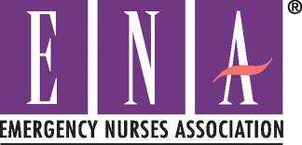

WNY Emergency Nurses Association Briefing December 2013

Thank you to Dawn Specht, RN, ANP for an excellent presentation on Stroke made E.A.S.Y. Thank you to our sponsor Ken Livingston, CRTX Therapeutics, for an excellent dinner at Classics V Banquet Center.

Website
www.wnyena.com.

Home page connects WNY ENA with links to national ENA and membership.
This site has guides to classes, conferences, registration, downloadable forms and future meetings.

2014 Officers

President – Renee Sylvies, RN
Treasurer – Roseann Mohney, RN
Secretary – Open Position (online training available)

Leadership Conference

March 5-9, 2014 Phoenix Convention Center, Phoenix, AZ. Reservations required http://www.ena.org (online payments accepted).

Setting the Pace Conference

April 10, 11, 2014 RIT Conference Center in Rochester, NY. Reservations required: http://www.nysena.org (online payments accepted).

National ENA Conference

October 7-11, 2014 in Indianapolis, IN. More information to follow.

CEU’s

Go green! CEU’s available online at http://nursece4less.com/

Next Meeting

February 12, 2014 at 6 pm DeGraff Community Center (across from DeGraff Hospital)
139 Division Street
No. Tonawanda, NY 14210

Topic: Reiki
Stress reduction, peace, harmony and healing.
Does Reiki have a place in the emergency room?

RSVP @ 523-1853 or westernnewyorkena@verizon.net or find us on Facebook.

RN members, RN non-members, LPN’s, student nurses, retirees and paramedics are welcome.

Your input to make our meetings better is always welcome!

